**Additional Material on Multimedia**

**Exercise 1**: Study the diagram of Mouse below and answer the following questions.

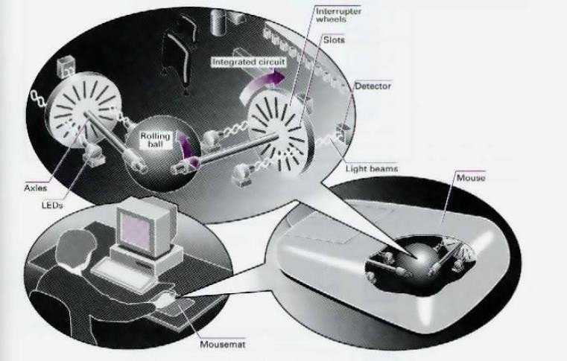

1. Move the mouse to the left and the cursor moves to the left .
2. The mouse contains a rolling balls.
3. There are two axles inside the mouse and two interrupter wheels.
4. When you move the mouse, the ball .
5. The mouse moves over a mousemat . Now read this text to check your answer.

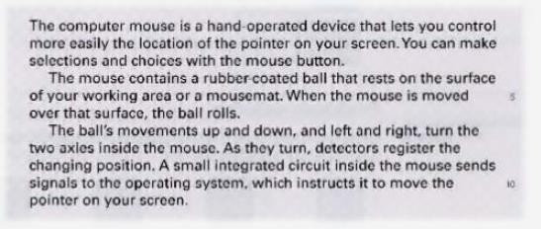

**Exercise 2**: Study the information about the keys on the keyboard. Then look at the statements (1-7) and correct the ones which are wrong.

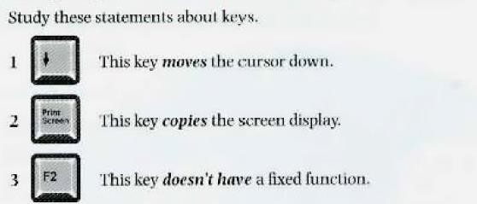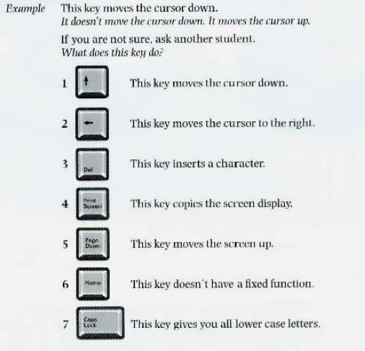

**Exercise 3**: With the help of the table, write a brief description of a keyboard. Look at the example below.

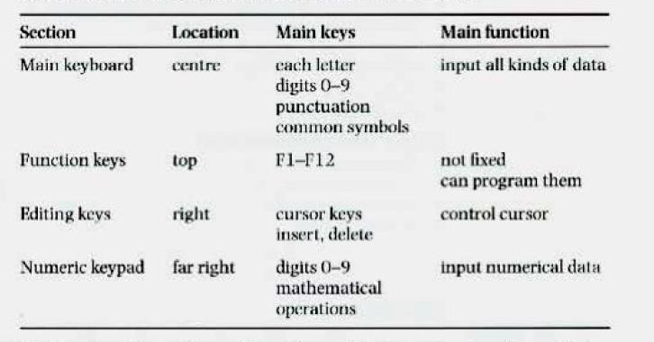

Most keyboards have four sections. The main keyboard has keys for each letter and the digits 0 to 9. It also has keys for punctuation and other common symbols. It is used for inputting all kinds of data.

.

.

.